C29PE Tutorial 6 Questions with Answers – The Economy as a System

- The following table shows UK labour market data for the first quarter of 2022 (seasonally adjusted, all aged 16 and over).
  - Fill in the blank parts of the table.
 | Male | Female | Total
In employment (000s) | 17 049 | 15 583 | 32 632
ILO unemployed (000s) | 694 | 565 | 1 259
Total economically active (000s) | 17 743 | 16 148 | 33 891
Percentage unemployed (%) | 3.9 | 3.5 | 3.7

  - Repeat the exercise undertaken in 1(a), but this time for those aged 18–24.
 | Male | Female | Total
In employment (000s) | 1 406 | 1 283 | 2 689
ILO unemployed (000s) | 167 | 85 | 252
Total economically active (000s) | 1 573 | 1 368 | 2 941
Percentage unemployed (%) | 10.6 | 6.2 | 8.6

  - Calculate the percentage point differences for the first quarter of 2022 in the following:
    - The overall (aged 16 and over) male and female unemployment rates
0.4 percentage points
    - 18–24 (male unemployment) and overall male unemployment rates 6.7 percentage points
    - 18–24 (female unemployment) and overall female unemployment rates 2.7 percentage points
    - 18–24 (total unemployment) and overall total unemployment rates 4.9 percentage points

- The following diagram shows the aggregate demand and supply of labour and the total labour force (N). Assume initially that there is no disequilibrium unemployment. Assume that there is a contraction of aggregate demand and that, as a result, there is a recession. Assume also that wage rates are ‘sticky’ downwards and as a result do not fall.
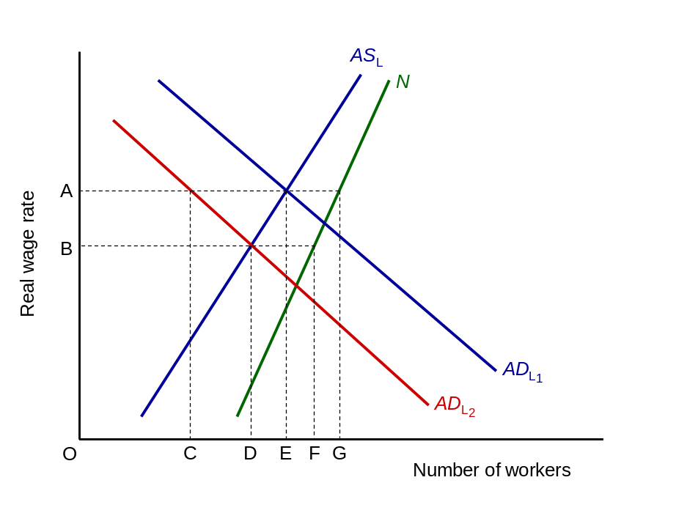
  - What is the initial level of employment? OE, where AD_{L1} = AS_{L}
  - What is the initial level of unemployment?
EG (the total labour force (N) minus the number unemployed. (This is purely equilibrium unemployment.)
  - What is the level of employment after the onset of recession?
OC (the number of workers demanded at the wage rate of OA)
  - What is the total level of unemployment now? CG
  - How much is equilibrium unemployment? EG
  - How much is disequilibrium unemployment? CE
  - Assume now that wage rates are not sticky downwards and fall to the equilibrium. How much is unemployment now?
DF (the difference between AS_{L} and N at the new equilibrium wage rate of OB)

- Given the following data on UK expenditure in 2010:
£bn
Final consumption expenditure by households and non-profit institutions 1004.1
Government final consumption expenditure 336.6
Gross fixed capital formation 250.2
Changes in inventories +4.5
Imports of goods and services 484.1
Net income from abroad +17.2
Exports of goods and services 447.1
Fixed capital consumption (depreciation) 207.6
  - Calculate:
    - Gross domestic product (at market prices)
£1004.1bn + £336.6.bn + £250.2bn + £4.5bn – £484.1bn + £447.1bn = £1558.4bn
  - Net national income £1558.4bn +£17.2bn – £207.6bn = £1368.0bn
  - The percentage shares of GDP comprising each component of expenditure:
Final consumption expenditure by households and non-profit institutions 64.4
Government final consumption expenditure 21.6
Gross fixed capital formation 16.1
Changes in inventories +0.3
Imports of goods and services –31.1
Exports of goods and services 28.7

Sample exam questions

- In an economy where taxes equal £40m, exports, government expenditure and investment expenditure are each equal to £200m. Households consume 75% of their disposable income. Imports equal 25% of national income. Define the concept of the circular flow of income in the economy, illustrating your answer.
Students can use the following steps in answering this question.
Step 1: Define the circular flow of income, also explaining injections and leakages and how each component interacts with the firms and households.
Step 2: Calculate the national income using the data provided.
Step 3: Then, calculate when the national income is at equilibrium (injections=withdrawals).
Step 4: Lastly, illustrate this with the circular flow of income diagram. Diagram with flow of goods and services from firms to households and supply or factors of production from households to firms, with financial flows (payments for goods and services, wages of labour + interest on capital) flowing in the opposite direction.

- For many years, economists have used the term ‘business cycle’ to refer to the succession of periods of economic expansion, followed by recession, over approximately 7 – 9 years. An important objective of government economic policy is to manage these fluctuations. Briefly outline the links between the business cycle and the credit cycle in banking.
Students should note that the cycle is often associated with changes in the availability of credit, which in turn reflect confidence in the future path of the economy. Banks make investment funds available at times when economic prospects seem positive, and they are confident of borrowers repaying. However, suffering losses from loan failures, banks need to rebuild their balance sheets, and raise more capital. While doing that, they reduce lending, so that investment declines rapidly, and economic growth declines. This can cause a loss of confidence in future economic prospects, leading to a decline in the demand for investment funds.

Supplementary questions (will not be discussed in class)

- Position each of the following eight terms in the UK’s circular flow of income diagram.
  - Consumption (of domestically produced goods and services);
  - Net saving;
  - Net taxation;
  - Government expenditure;
  - Factor payments (national income);
  - Expenditure on imports;
  - Investment;
  - Expenditure on exports.

Economists use specific letters to label each of these terms. The letters used are:
S, G, X, M, I, C_{d}, T, Y. Attach the correct letter to each of the terms you have written on the diagram.
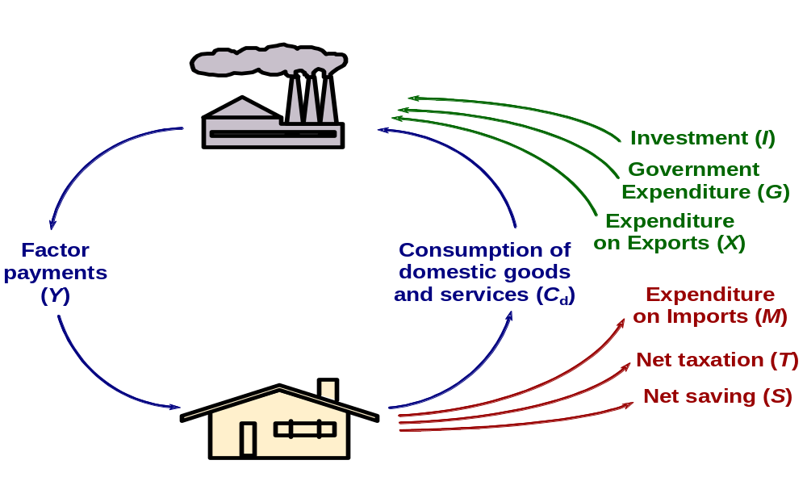

- Which of the following relate to changes in injections into, and which are changes in withdrawals from the UK’s circular flow of income? In each case, identify whether the change is an increase or a decrease. In each case, assume that this is the only change. (Delete wrong words.)
  - A council funds the building of new libraries. Injection Increase
  - The government raises tax-free thresholds. Withdrawal Decrease
  - The government reduces child benefit. Withdrawal Increase
  - Fewer tourists visit the UK. Injection Decrease
  - Firms, anticipating a rise in consumer demand, borrow more money in order to build up their stocks. Injection Increase
  - Consumers demand more goods than are domestically produced (but total consumption does not change). Withdrawal Decrease
  - People invest more money in banks and building societies. Withdrawal Increase

- Given the following possible types of unemployment − demand-deficient, real-wage (wage push), frictional, structural, regional, technological and seasonal − which one is likely to worsen in each of the following cases? (There may be more than one case of a particular type.)
  - The introduction of robots in manufacturing. Technological
  - The economy moves into recession. Demand-deficient (cyclical)
  - Legislation is passed guaranteeing everyone a minimum wage that is 80% of the national average. Real-wage
  - The government decides to close job centres in an attempt to save money.
Frictional (and demand-deficient)
  - The Bank of England raises interest rates. Demand-deficient

- The following diagram shows an aggregate demand curve and an aggregate supply curve.
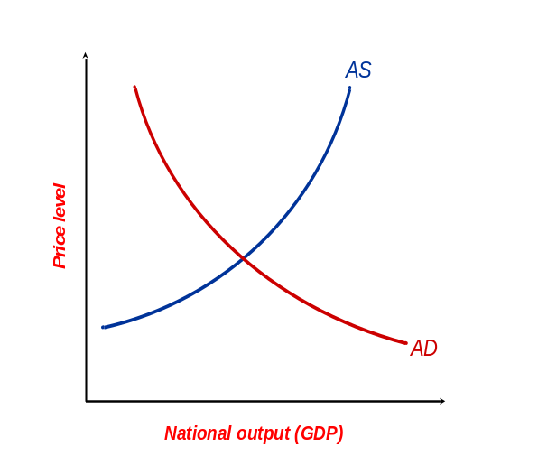
  - Label the two axes. See diagram.
  - Give three reasons why the AD curve is downward sloping.
As the (domestic) price level rises, people will buy more imports and demand fewer domestic goods.
As the price level rises, people will need more money to pay for goods. The extra demand for money will drive up interest rates and dampen demand.
As the price level rises, the value of people’s savings will be eroded. They may therefore save more (and hence demand fewer goods) to help restore the value of their savings.
  - Why is the AS curve upward sloping (at least in the short run)?
Higher prices will encourage firms to produce more (assuming that factor prices do not rise as rapidly as the prices of goods and services).
  - Suggest two changes in the economic environment which could shift the AD curve to the right.
Increased government spending. Increased investment (e.g. if firms anticipate a growth in their markets).
  - Suggest two changes in the economic environment which could shift the AS curve to the right.
A rise in labour productivity. An increase in the stock of capital.

- Will the following lead to cost-push or demand-pull inflation, or both?
  - The Bank of England cuts interest rates and the economy booms. Demand-pull
  - As a result of falling unemployment, trade unions become more militant and demand higher wages. Both
  - The government raises the rate of VAT. Cost-push
  - The government cuts income tax rates and raises government expenditure at a time of near full employment. Demand-pull
  - Increasing industrial concentration leads to more oligopolistic collusion to raise prices. Cost-push

